Project Implementation Report
Crop Recommendation Based on Soil and Climate Conditions
Method, measured results, input validation and limitations
Summary. A Random Forest ranks ten crop labels from seven soil and climate inputs. On 90 held-out rows its single highest-scored crop is correct 83.3% of the time (test accuracy), and the true crop is among its three highest-scored crops 96.7% of the time (top-3 accuracy). These two numbers answer different questions and are not interchangeable (Section 6.2). The data are of undocumented origin and almost certainly synthetic, so all results are software-validation results, not evidence of agronomic performance. The Streamlit app warns users when an input is outside, or unlike, the data the model was fitted on (Section 7).

1. Purpose and scope
The prototype maps seven numeric inputs (nitrogen N, phosphorus P, potassium K, temperature, humidity, soil pH and rainfall) to one of ten crop labels: barley, chickpea, coffee, enset, haricot bean, maize, sesame, sorghum, teff, wheat. The user-facing output is the three crops with the highest model scores. Scores are the model's class probabilities; they are not predicted yields, fertilizer prescriptions or calibrated real-world probabilities.

2. Dataset and its provenance
The supplied file has 600 rows, 7 numeric features and a label column with 10 crops (60 rows each). It arrived without documentation: no author, collection site, dates, units or labelling protocol. The file name and crop names suggest an Ethiopian focus, but nothing shows that any row is a field observation.
The notebook tests whether the rows look like field data or like simulated draws. Table 1 summarises the checks; all point towards generated data. This is an inference from the data, not a documented fact.
Table 1. Evidence on how the rows were produced (outputs/data_provenance_checks.csv).
Check | Result | How to read it
Rows per crop (min / max) | 60 / 60 | Exactly balanced
Class-by-feature distributions consistent with normal (Shapiro p>0.05) | 100% of 70 | Expect ~95% if normal; real field data usually fails some
Mean |within-crop correlation| between features | 0.100 | Independent draws give ~0.104
Mean |correlation| across all rows pooled | 0.243 | Higher only because crops differ in their means
Rainfall SD across crops (min / max) | 131 / 153 | Near-constant spread
Rainfall mean across crops (min / max) | 441 / 1415 | ...while the means differ about 3x
Rainfall coefficient of variation across crops | 10% / 31% | Real variability usually scales with the mean
Rows with humidity at exactly 100 / rainfall at exactly 100 | 1 / 1 | Signature of clipping generated values at a bound
Share of values with more than 6 decimal places | 100% | Instrument readings are rounded

Consequence: the label is the crop a row was generated for, not a recorded outcome such as the crop a farmer grew or the best-yielding crop. The model learns to separate ten generated, overlapping profiles. Our preparation step only validates the file (numeric conversion, removal of missing or non-finite rows, trimming and lower-casing of labels); no rows were generated, augmented or edited by us.

3. Exploratory data analysis

3.1 Class balance
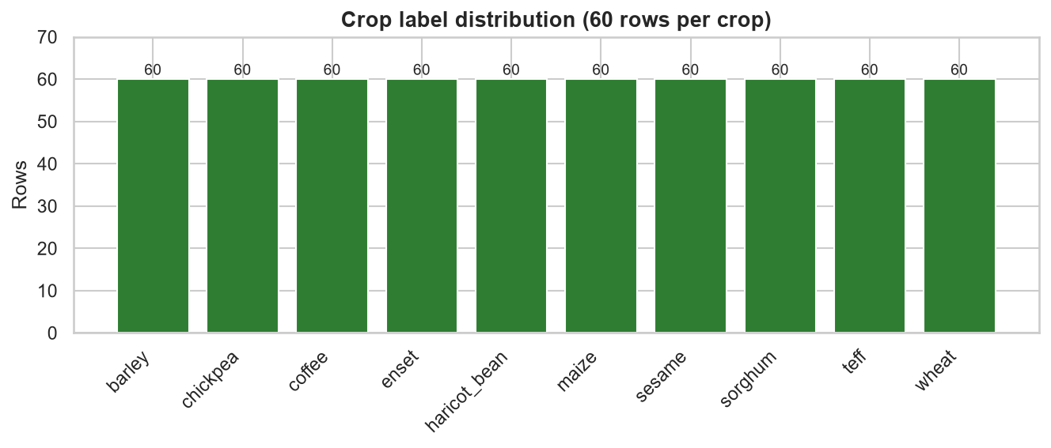
Figure 1. Number of rows per crop label (60 each, 600 in total).
Every crop has exactly 60 rows. Because the classes are balanced, plain accuracy is not distorted by a dominant class, and the majority-class baseline scores 10% (Section 5). Exact balance is also one of the signals that the file is generated rather than collected (Table 1).

3.2 Feature distributions
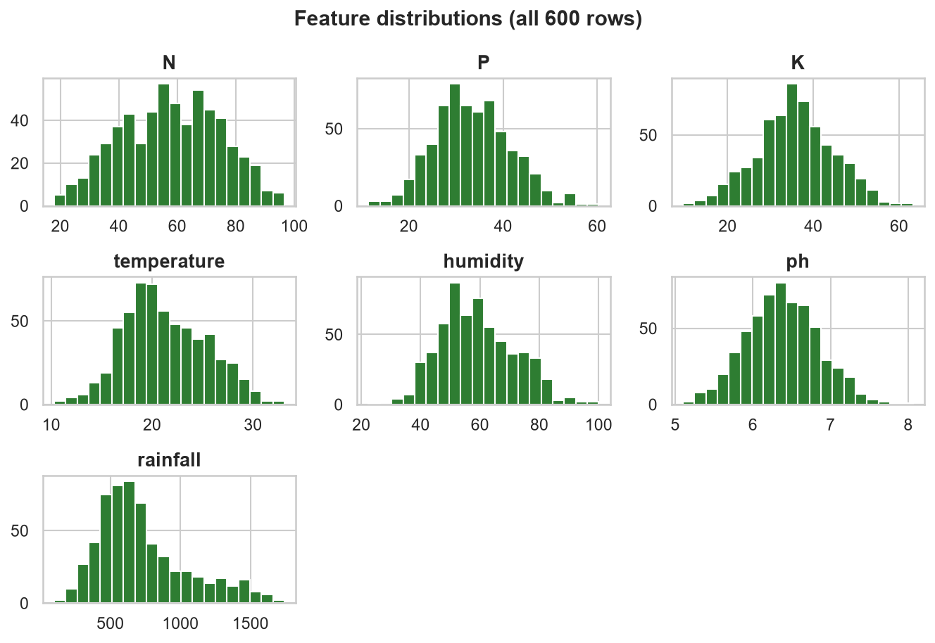
Figure 2. Distribution of each input feature over all 600 rows.
Ranges in the file are: N 17.97 to 96.63; P 11.44 to 60.3; K 9.58 to 63.23; temperature 10.31 to 33.11; humidity 22.46 to 100; ph 5.098 to 8.061; rainfall 100 to 1742. These are the ranges the model learns from; the app compares user inputs with them (Section 7). Rainfall has the widest spread (mean 730, SD 322); humidity reaches exactly 100 and rainfall exactly 100 in one row each, which is consistent with clipping at a bound.

3.3 Correlation between features
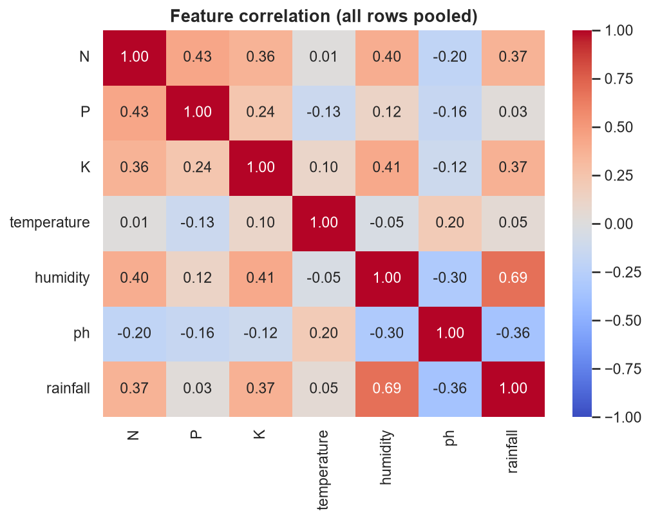
Figure 3. Pearson correlation between features over all 600 rows.
The strongest pooled correlation is between humidity and rainfall (0.69). Pooled correlations are higher than within-crop correlations (mean absolute 0.243 pooled against 0.100 within crops, Table 1) only because the crops have different means; inside a crop the features behave as independent draws, another sign of generated data.

3.4 How the features differ between crops
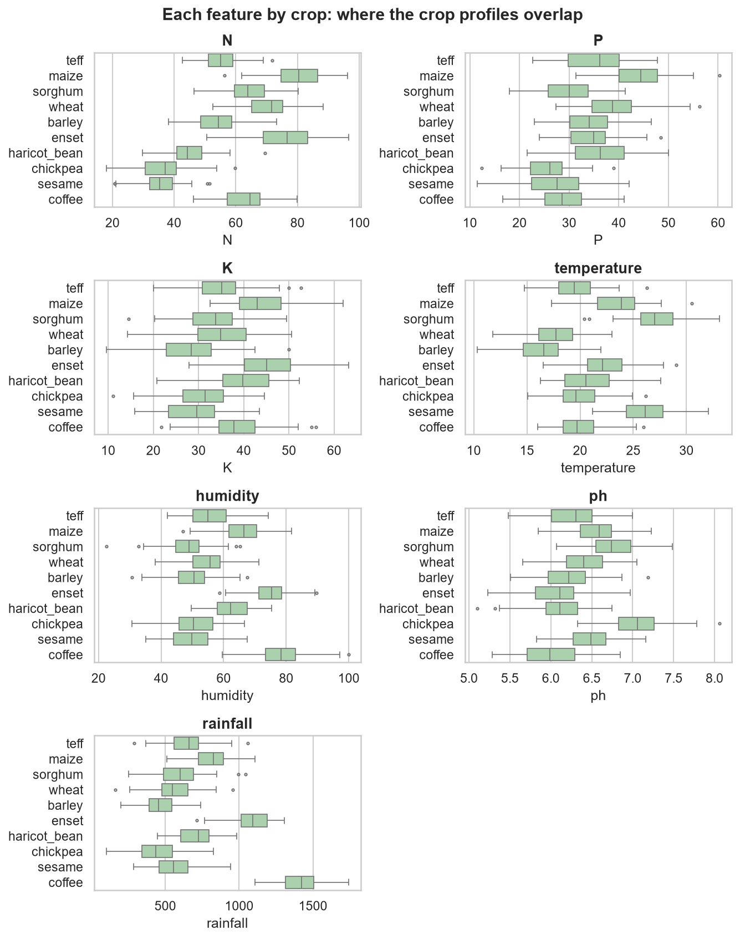
Figure 4. Each feature by crop. Overlapping boxes mean a feature alone cannot separate those crops.
Several features separate some crops clearly: mean rainfall ranges from 441 (chickpea) to 1415 (coffee), mean temperature from 16.3 (barley) to 27.1 (sorghum), and mean N from 35 (sesame) to 80 (maize). But many crops overlap on most features, so no single feature classifies the rows; that overlap is what produces the confusions in Section 6.3.

4. Method
- Split. Stratified 70 / 15 / 15 split with random_state 42: 420 training, 90 validation and 90 test rows (9 test rows per crop).
- Candidates. Majority-class baseline, Decision Tree, Gradient Boosting and Random Forest.
- Selection. The model with the highest validation Macro-F1 was chosen, then refitted on training plus validation rows (510 rows). The 90 test rows were used once, for the final evaluation, and the saved model never saw them (checked by verify_saved_model.py).
- Stability check. Five-fold cross-validated Macro-F1 over all 600 rows. This is supplementary and not an independent estimate, because its folds include the test rows.

5. Model comparison on the validation set
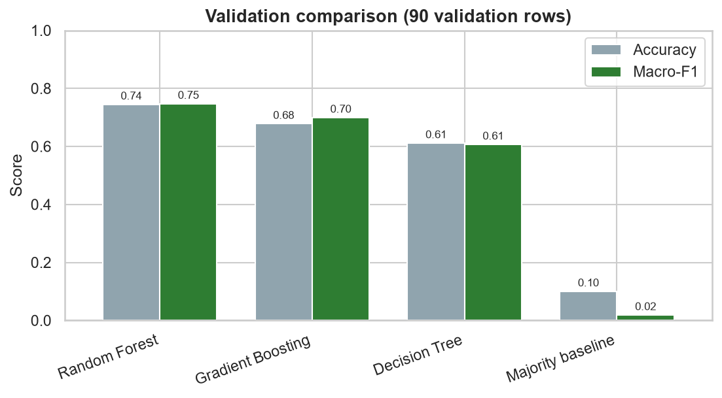
Figure 5. Validation accuracy and Macro-F1 for each candidate model.
Table 2. Validation results (90 rows). Random Forest was selected.
Model | Accuracy | Macro-F1 | Weighted F1
Random Forest | 0.744 | 0.747 | 0.747
Gradient Boosting | 0.678 | 0.699 | 0.699
Decision Tree | 0.611 | 0.606 | 0.606
Majority baseline | 0.100 | 0.018 | 0.018

Random Forest scored the highest validation Macro-F1 (0.747), ahead of Gradient Boosting (0.699). All three learned models are far above the 10% baseline. With only 90 validation rows each row is worth 1.1 percentage points, so small gaps should not be over-read; the gap between Random Forest and the single Decision Tree is large enough to be meaningful.

6. Results on the held-out test set

6.1 Headline metrics
Table 3. Random Forest on the 90 held-out test rows.
Metric | Value | Meaning
Test accuracy (top-1) | 0.833 | 75 of 90 rows
Macro precision | 0.836 | mean over 10 crops
Macro recall | 0.833 | mean over 10 crops
Macro-F1 | 0.831 | mean over 10 crops
Top-3 accuracy | 0.967 | 87 of 90 rows
Five-fold CV Macro-F1 | 0.802 (SD 0.029) | all 600 rows; supplementary

6.2 Test accuracy versus top-3 accuracy
The two headline numbers answer different questions and measure different things:
- Test accuracy (top-1) asks: is the single highest-scored crop the true label? It is 83.3% (75/90). This is the strict measure of how often the first recommendation is right.
- Top-3 accuracy asks: is the true label anywhere among the three highest-scored crops? It is 96.7% (87/90). This matches the list the app displays, but it is an easier test: a row counts as correct even when the true crop is only second or third.
Top-3 accuracy is always at least as high as test accuracy, and the gap between them is exactly the rows where the true crop was the model's second or third choice. Here that is 12 rows (13.3% of the test set): 10 in second place and 2 in third. Only 3 rows (3.3%) had the true crop outside the top three.
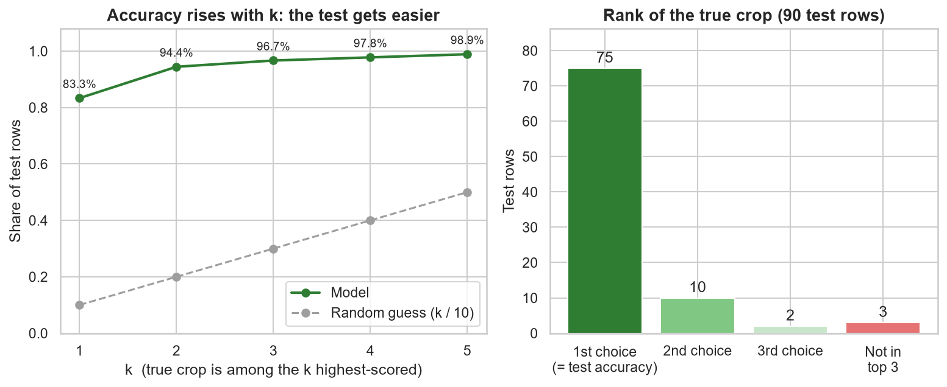
Figure 6. Left: accuracy as k grows (the test gets easier, and random guessing rises with it). Right: where the true crop ranked among the 90 test rows; the first bar is the test accuracy.
Table 4. Accuracy when the true crop only has to be among the k highest-scored crops (outputs/top_k_accuracy.csv).
Measure | Rows correct | Accuracy | Random guess | Gain over random
Top-1 (= test accuracy) | 75 / 90 | 83.3% | 10% | 8.3x
Top-2 | 85 / 90 | 94.4% | 20% | 4.7x
Top-3 | 87 / 90 | 96.7% | 30% | 3.2x
Top-4 | 88 / 90 | 97.8% | 40% | 2.4x
Top-5 | 89 / 90 | 98.9% | 50% | 2.0x

How to read the two numbers together:
- Random guessing gives 10% for top-1 and 30% for top-3, so both results are far above chance; the top-1 result is 8.3 times chance and the top-3 result 3.2 times chance. Top-3 looks larger in absolute terms mainly because the test is easier, not because the model is better at it.
- Top-3 accuracy does not say which of the three crops is right. A user who sees three crops and is told one is correct still has to choose; in 12 of the 87 top-3 hits the correct crop was not the one ranked first.
- With 90 test rows the estimates are imprecise: a 95% Wilson interval is 74% to 90% for test accuracy and 91% to 99% for top-3 accuracy, and one row moves either by 1.1 percentage points.
Worked example. For the app's default input (N 60, P 30, K 35, temperature 22, humidity 60, pH 6.4, rainfall 700) the model returns teff (56%), wheat (17%) and haricot bean (8.3%). Test accuracy is about whether teff alone is right; top-3 accuracy is about whether the right crop is any of these three. Note also that a displayed score such as 59% is a model score, not a calibrated probability that this crop is right.

6.3 Confusion matrix
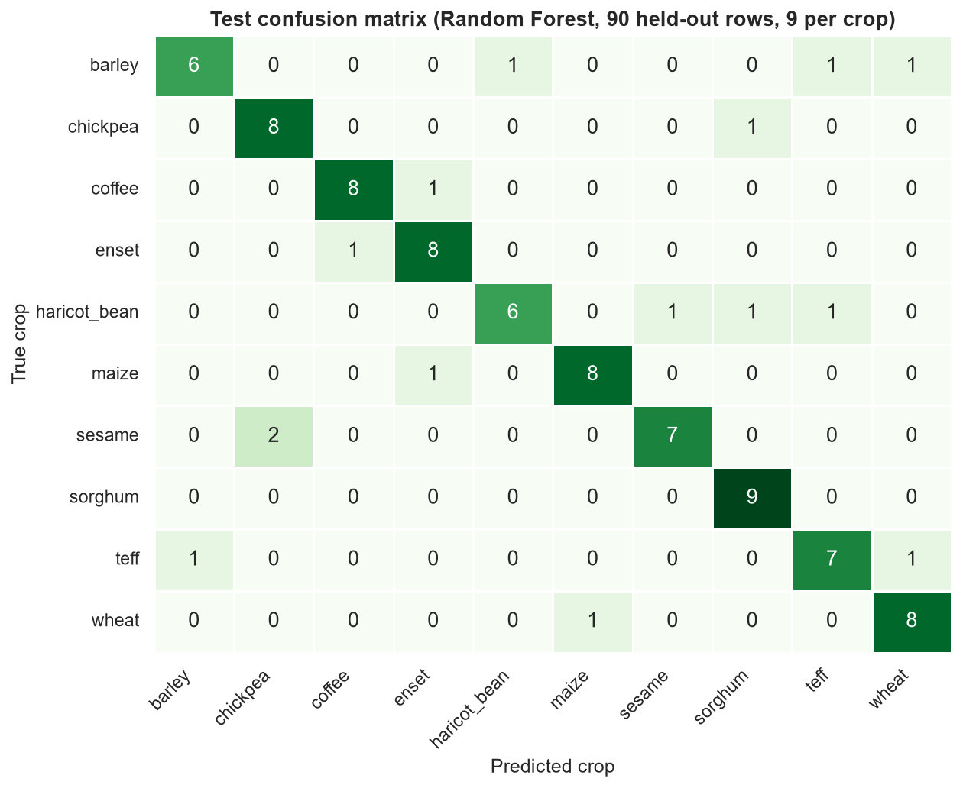
Figure 7. Confusion matrix on the 90 test rows (rows = true crop, columns = predicted crop; 9 rows per crop).
The diagonal holds the 75 correct predictions; the 15 errors are spread over 14 different true-to-predicted pairs, and no pair occurs more than 2 times. There is therefore no single dominant failure, although with 9 rows per crop this cannot be proven either way.
Table 5. Every misclassification pair on the test set (outputs/top_confusions.csv).
True crop | Predicted as | Rows
sesame | chickpea | 2
barley | haricot bean | 1
barley | teff | 1
barley | wheat | 1
chickpea | sorghum | 1
coffee | enset | 1
enset | coffee | 1
haricot bean | sesame | 1
haricot bean | sorghum | 1
haricot bean | teff | 1
maize | enset | 1
teff | barley | 1
teff | wheat | 1
wheat | maize | 1

The most frequent confusions (two rows each) are sesame as chickpea. Some of these pairs have similar profiles in the data; for example maize and enset have similar mean N (80 and 76) and mean K (44 and 45). Because the profiles are generated, these overlaps describe the dataset and not real-world crop similarity.

6.4 Class-level results
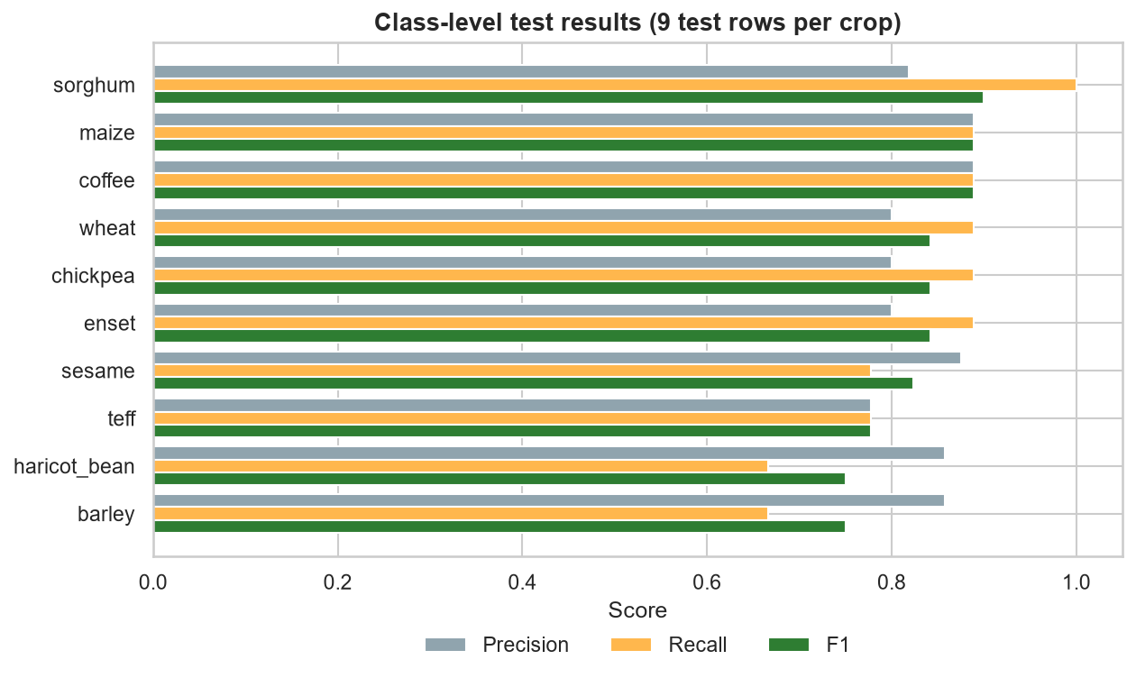
Figure 8. Precision, recall and F1-score for each crop on the test set.
Table 6. Per-crop test results (outputs/per_class_metrics.csv; support = test rows per crop).
Crop | Precision | Recall | F1-score | Support | Correct
barley | 0.86 | 0.67 | 0.75 | 9 | 6 / 9
chickpea | 0.80 | 0.89 | 0.84 | 9 | 8 / 9
coffee | 0.89 | 0.89 | 0.89 | 9 | 8 / 9
enset | 0.80 | 0.89 | 0.84 | 9 | 8 / 9
haricot bean | 0.86 | 0.67 | 0.75 | 9 | 6 / 9
maize | 0.89 | 0.89 | 0.89 | 9 | 8 / 9
sesame | 0.88 | 0.78 | 0.82 | 9 | 7 / 9
sorghum | 0.82 | 1.00 | 0.90 | 9 | 9 / 9
teff | 0.78 | 0.78 | 0.78 | 9 | 7 / 9
wheat | 0.80 | 0.89 | 0.84 | 9 | 8 / 9

Recall is lowest for barley (0.67, 6 of 9 found) and highest for sorghum (1.00, all 9 found). Precision is lowest for teff (0.78): other crops were sometimes predicted as teff. Sesame has precision 1.00 but recall 0.78, meaning it was never predicted wrongly but two sesame rows were assigned to chickpea.
Caution. Each crop has only 9 test rows, so one row changes a recall value by 0.11. The differences between crops are suggestive and should not be treated as reliable rankings of crop difficulty.

6.5 Feature importance
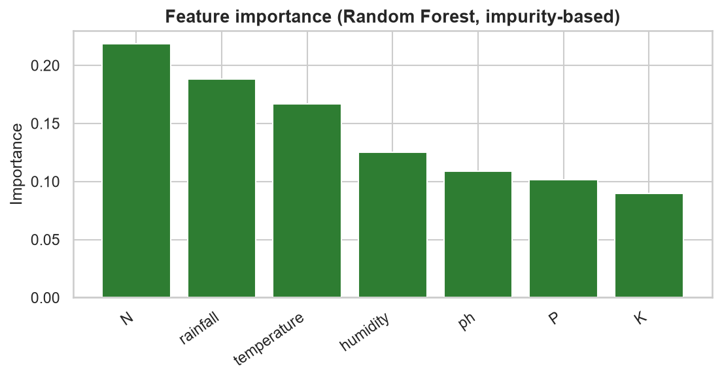
Figure 9. Random Forest impurity-based feature importance.
The largest contributors are N (0.22), rainfall (0.19) and temperature (0.17); K is the smallest (0.09). Importance describes how the model splits this dataset; it is not evidence that these variables drive crop choice in the field.

7. Input validation in the Streamlit app
A valid number is not necessarily a reliable input for this model. Before the revision, the app only enforced physical limits (pH 0 to 14, humidity 0 to 100%, no negative nutrients or rainfall). Inside those limits it still returned a confident-looking ranking for values the model had never seen: for temperature −5 and rainfall 20, the model gives barley a 63% score. The app now compares every entry with the rows the model was fitted on (510 train + validation rows) and reports one of three outcomes:
- Outside the fitted range (below the minimum or above the maximum seen in training): a red "Low reliability" banner, a warning that names the feature, the value and the fitted range, and the ranking is labelled "low reliability".
- Edge of the fitted range (more extreme than 99% of fitted rows): a "Use with caution" message.
- Unfamiliar combination: every value is individually inside its range, but the combination is farther from every fitted row than the most unusual 1% of fitted rows are from their nearest neighbour (distance in standardised feature space, calibrated by leave-one-out on the fitted rows).
Warnings appear above the recommendation so they are read first. Each input also shows the fitted range in its help text, and an expander lists all ranges. The table below shows the fitted ranges that drive the checks.
Table 7. Fitted ranges used by the app. Outside min/max = low reliability; outside the 1st/99th percentile = caution.
Feature | Minimum | 1st percentile | 99th percentile | Maximum
N | 17.97 | 22.19 | 90.14 | 96.63
P | 11.44 | 16.29 | 53.8 | 60.3
K | 9.58 | 15 | 55.88 | 63.23
temperature | 10.31 | 12.94 | 30.41 | 33.11
humidity | 22.46 | 35.19 | 89.06 | 97.18
ph | 5.098 | 5.348 | 7.348 | 7.782
rainfall | 198.2 | 247.8 | 1588 | 1742

7.1 What the user sees
Table 8. The three scenarios in the screenshots below (outputs/input_check_examples.csv).
Input | Top crop | Score | Reliability | Warnings raised
Typical values | teff | 56% | familiar | none
Temperature -5, rainfall 20 (outside range) | barley | 55% | unreliable | outside range:temperature; outside range:rainfall
Each value ordinary, combination unusual | enset | 45% | unreliable | unfamiliar combination

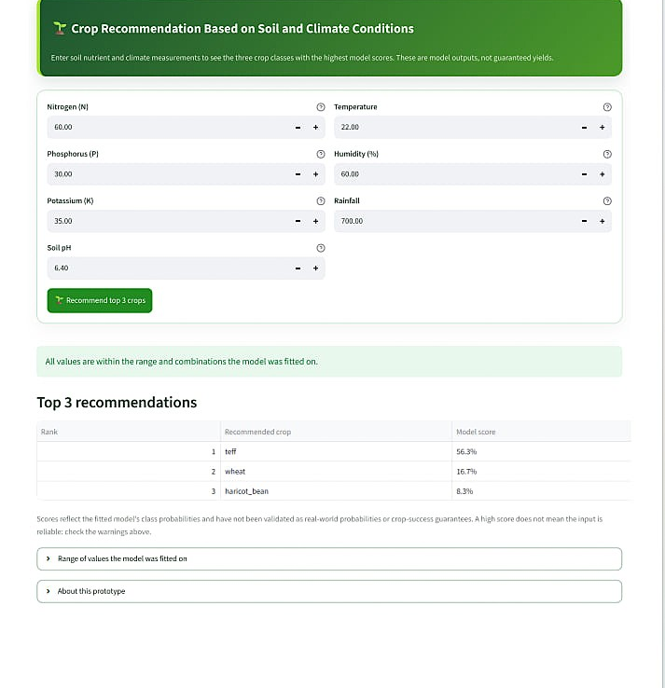  Figure 10. Typical values: green confirmation, no warnings. | 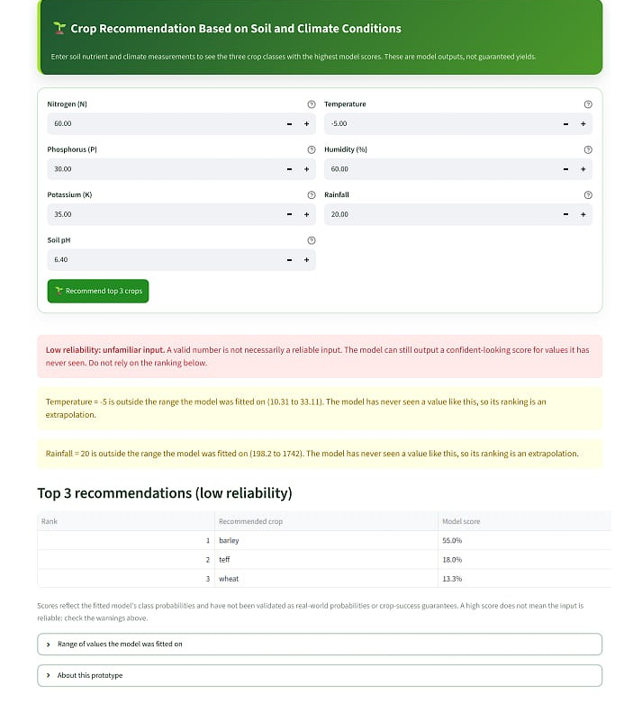  Figure 11. Temperature −5 and rainfall 20: red banner, named warnings, ranking labelled low reliability.
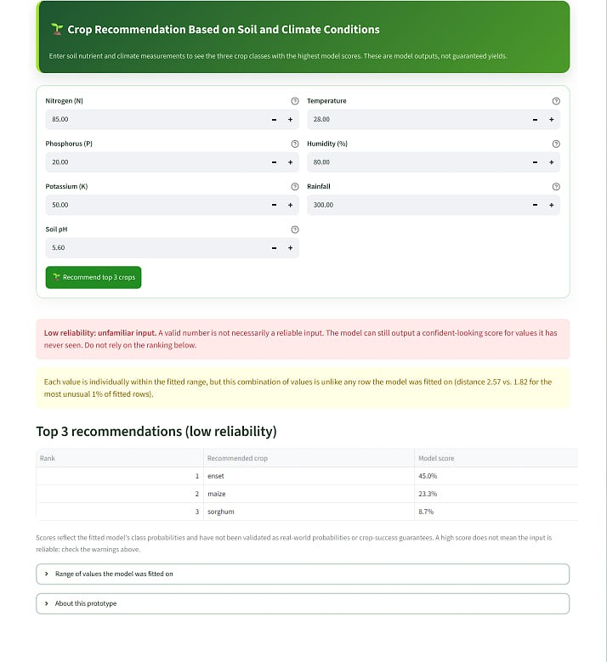  Figure 12. Ordinary values, unusual combination: flagged as low reliability. | 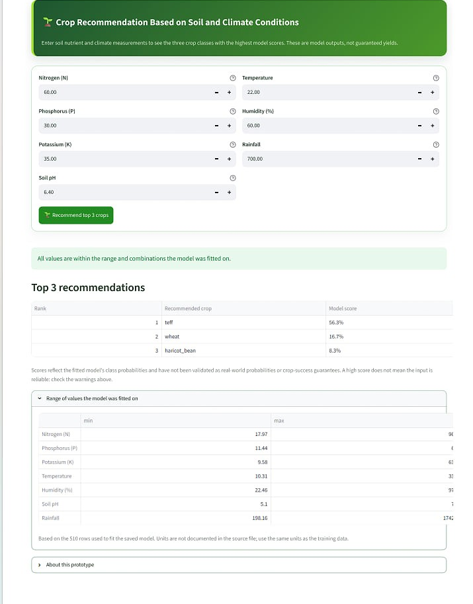  Figure 13. Expander listing the range the model was fitted on.

7.2 How noisy are the warnings?
Table 9. Check outcomes for the 90 real held-out rows and for 500 random combinations whose values all lie inside their individual fitted ranges (outputs/input_check_validation.csv).
Outcome | Test rows | Share | Random in-range combos | Share
familiar | 72 | 80% | 48 | 10%
edge | 14 | 16% | 56 | 11%
unreliable | 4 | 4% | 396 | 79%

A useful check should rarely flag rows that belong to the dataset and often flag combinations that do not. Of the 90 real test rows, 4 (4%) were flagged low reliability, all for a value just outside the fitted range of the 510 rows; none were flagged as an unusual combination. Of the random combinations, 79% were flagged, which shows the combination check catches inputs that pass every single-value test.
Limits of the check: it is a heuristic, not a guarantee. By design about 1% of fitted-like rows can be flagged, and the absence of a warning means only that the input resembles the training rows. Because those rows are synthetic and their units are undocumented, a familiar input is still not evidence of a good real-world recommendation.

8. Limitations
- Data origin. Undocumented and almost certainly synthetic; labels are generating categories, not field outcomes. Results are software-validation results only.
- Units. Not documented; users must enter values in the same units as the training data.
- Small test set. 90 rows (9 per crop); the 95% interval for test accuracy is 74% to 90%.
- Scores are not calibrated probabilities and have not been validated against real outcomes.
- Input checks are heuristic and depend on the same synthetic rows as the model.

9. Conclusion
The Random Forest recovers the generating crop for 83.3% of held-out rows at first choice and 96.7% within its top three, far above the 10% and 30% chance levels. The two numbers must be quoted together with their definitions: the first is the strict test and the second the easier one. The app now separates a valid number from a reliable one by warning on out-of-range values, edge values and unusual combinations. Before any operational use, the model must be re-fitted and validated with documented local field data and reviewed by agronomic experts.

Appendix: reproducing this report
- Run all cells of Ethiopian_Crop_Recommendation_Implementation.ipynb to regenerate outputs/, the model and model_metadata.json.
- python verify_saved_model.py confirms the saved model reproduces the reported test metrics.
- python test_input_checks.py and python test_app_validation.py test the input warnings.
- python build_report.py rebuilds this document from the saved results.

